WATER ROVER

Highlights:

* Low-cost
* Easy to make
* High payload capacity
* Stable design

Step 1: Calculate total Weight

* Select the equipments and payload to be added on the rover. This decides the total buoyancy required by the rover.
* Once the total weight required is decided, calculate the volume required to be displaced (Archimedes principle).

Buoyant force is given by: https://lh5.googleusercontent.com/he3de12IKOzXYybe07Q-nEODnw8WshUnAfIiCeM0lpvqMOsNulEzHhuoXH7WXRuGYUrQlJO6agKP9FknvIh78XmQY7Ahv0W3cxEqE_td0klhnSIyVWPwZOW7o3ZN3LhGpC4Llb0i

(rho here is density of water)

Note that the total force also includes the weight of the structure (hull) too and not just the payload.

Step 2: Selecting the appropriate propulsion system:

* The target waters for the rover are still and weedy waters. Conventional propulsion system has a potential to clog in weeds and needs to be cleared. Instead it was decided to use differential reaction drive for propulsion using two submersible pumps.
* The reaction drive works by having an intake which is located below the hull submerged in water. Water enters the pump through the inlet. The pump is usually centrifugal pump for higher speeds or axial flow type for medium or low speeds. The water pressure in increased inside the pump and is directed outward through a nozzle.

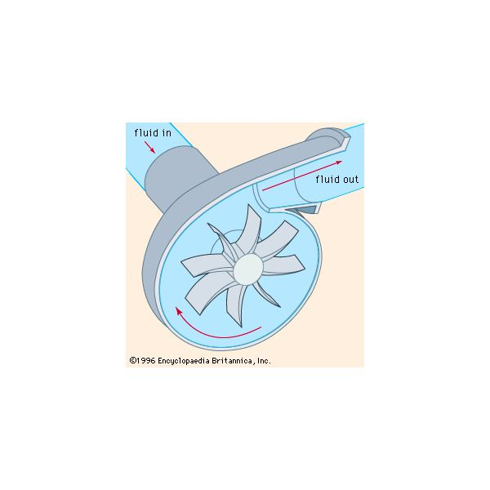

* The pump selected is Vetus V1000. 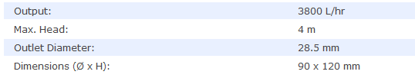

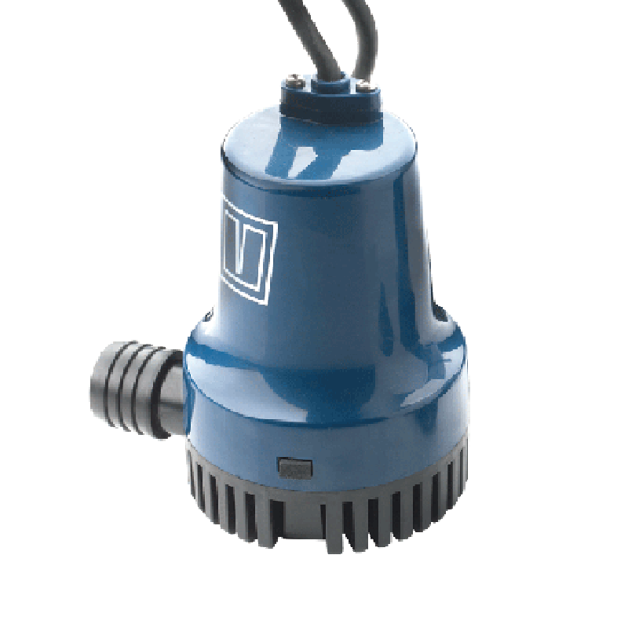

Step 3: Design

* Select the design of the rover as per the requirement.
* For simple construction and assembly, we have used raft like structure made of PVC pipes.
* We selected PVC pipes of 6” dia (16 cm); took three pipes of length 30 cm, 90 cm and 30 cm each. This gave us the total load capacity of about 30 kg (inclusive of the pipes own weight).

Volume of Pipes:

https://lh5.googleusercontent.com/zIZT0_KVxVx4l0aButMZHNdng9ibFHEunCHz6jmFXE7OhhELH9-DbIrmjZ7b297nNYZf5Pve8nB3OUP-PUqUmrgtIJQfTg8FmuSs_WNyv2gQBkWOKqtch204o3fUWOekFjwd5IzX

* Model it in CAD:

The relation between center of Buoyancy, center of gravity and the hull shape is very critical for the stability of the rover. CAD provides with the approximate points for their locations.

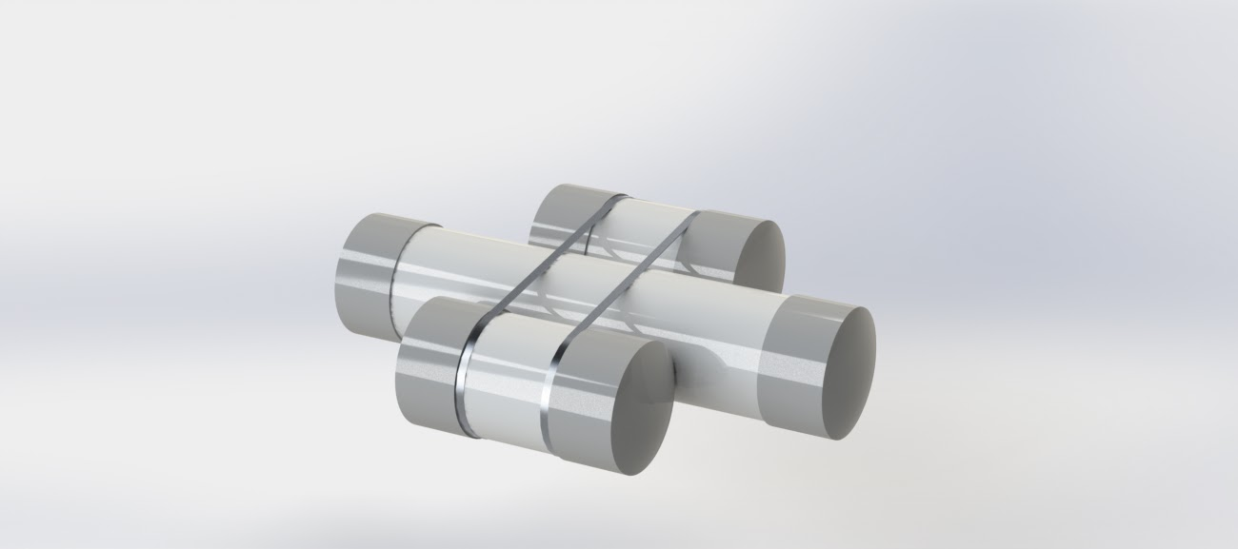

Support Structure

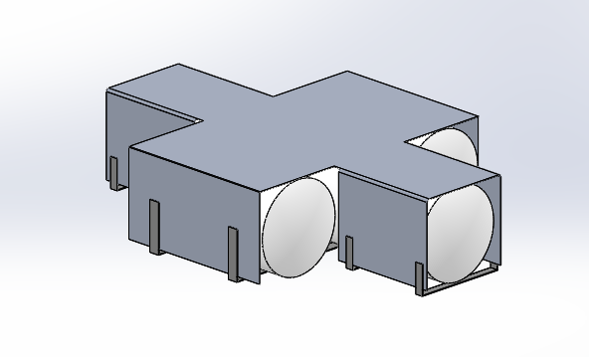

Mounting Plate with reinforcements

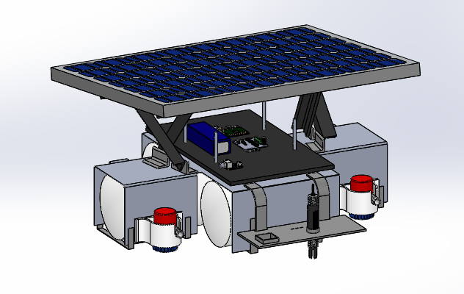

Final Model CAD

Step 4: Assembly

* Seal the pipe’s end with end caps and secure water-proofing using some solutions.
* Tie the three pipes together using metal strips or lock ties. Bond them together using a strong waterproof adhesive.

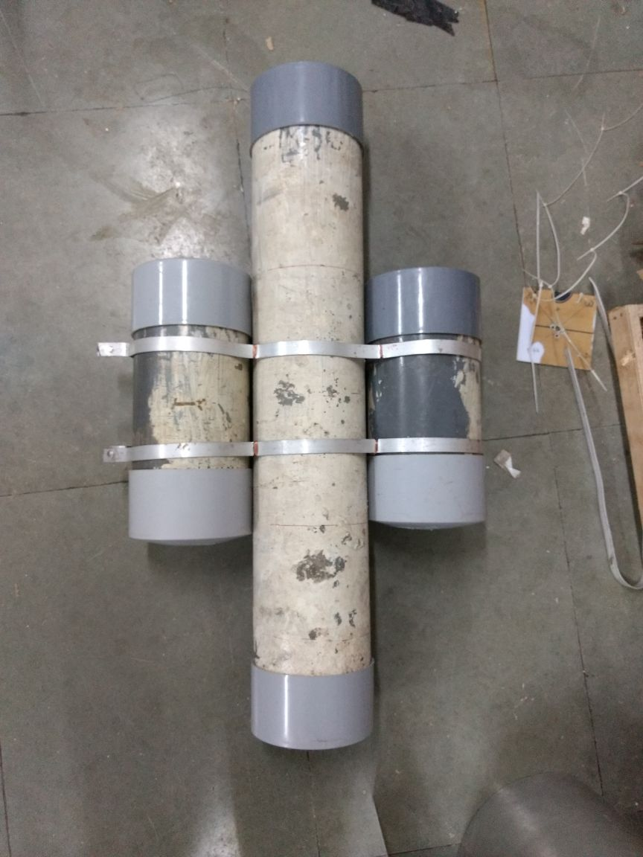

* Since PVC pipes are not UV stabilized, we coated them with oil paint.

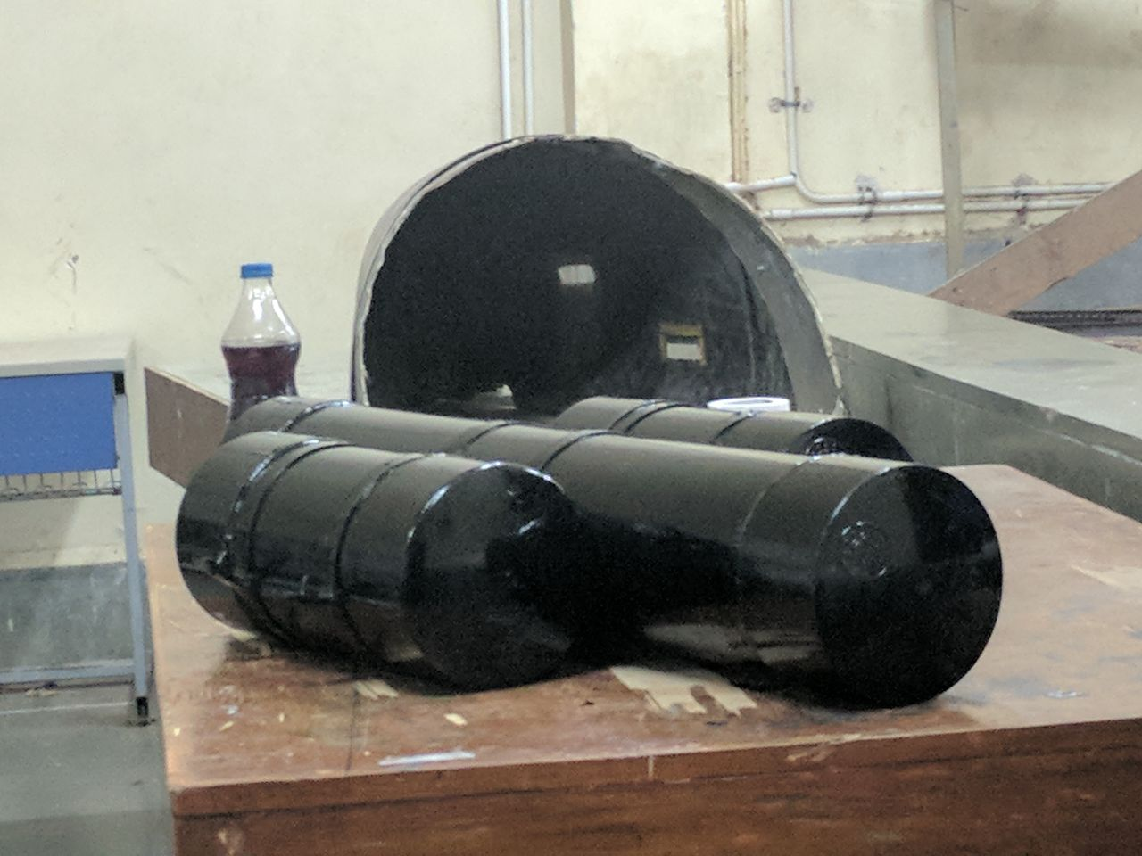

* Next cutout a sheet of non-corrosive metal like aluminium and bend it to conform to the shape of the pipes.

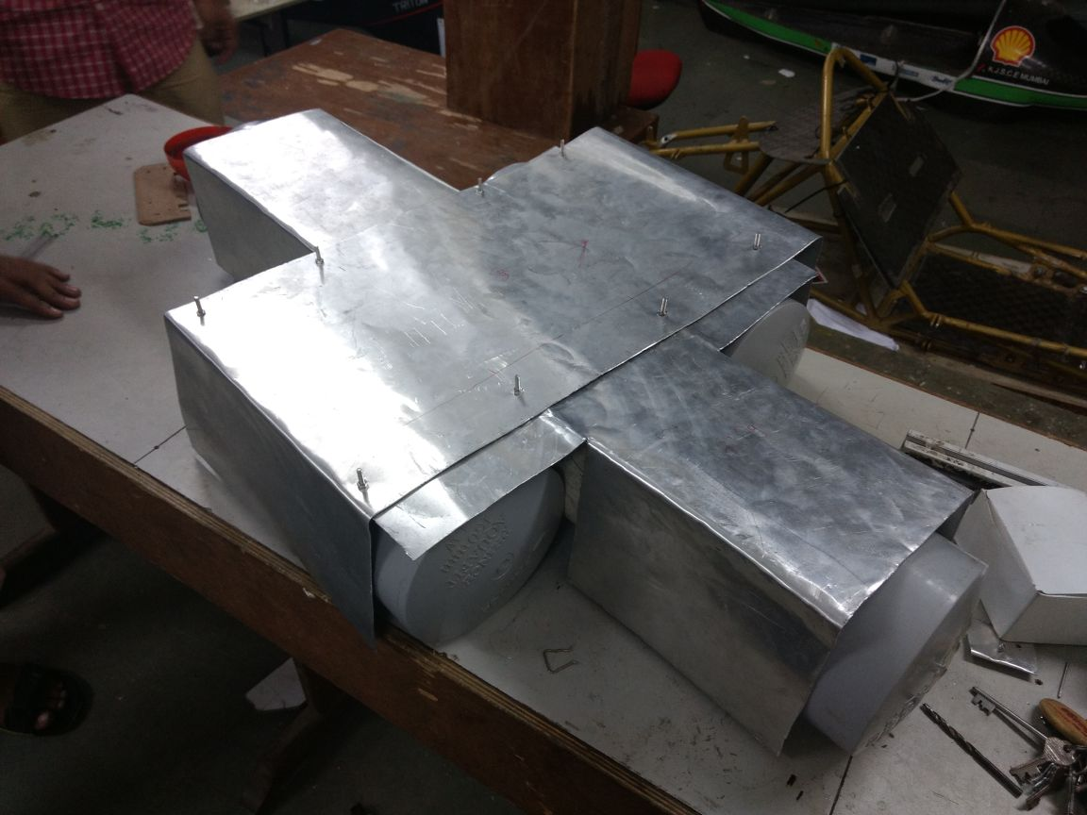

* Secure the aluminium plate to the pipes. We used U-brackets.

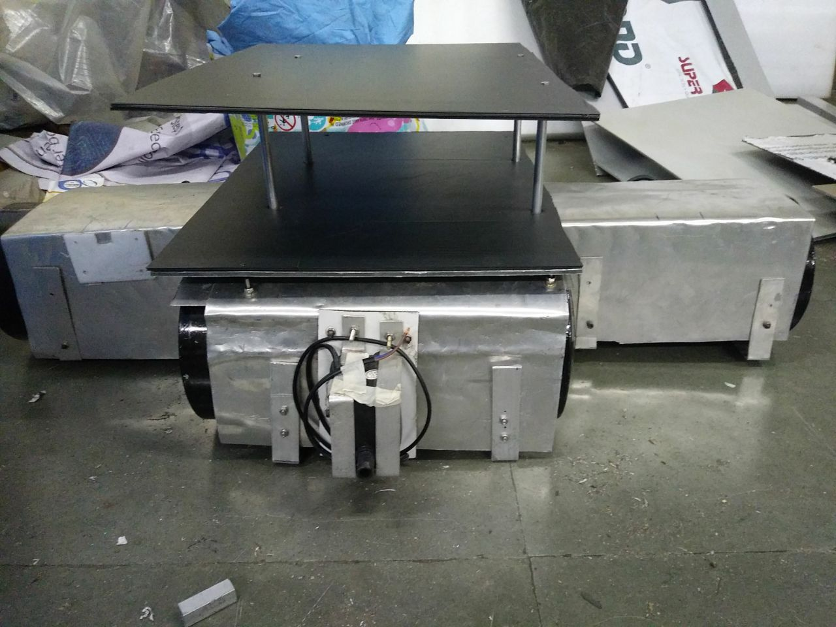

* Attach the pumps to the aluminium sheet.

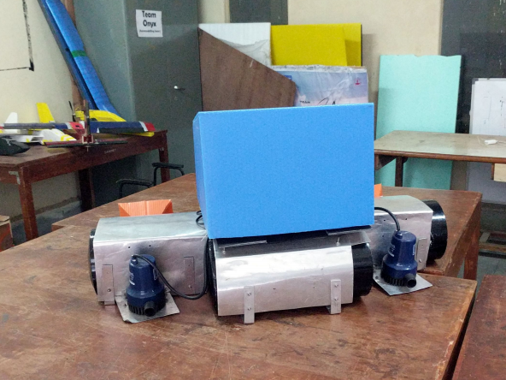

* Place a box on the top of the rover which can contain all the circuits and route the wires.